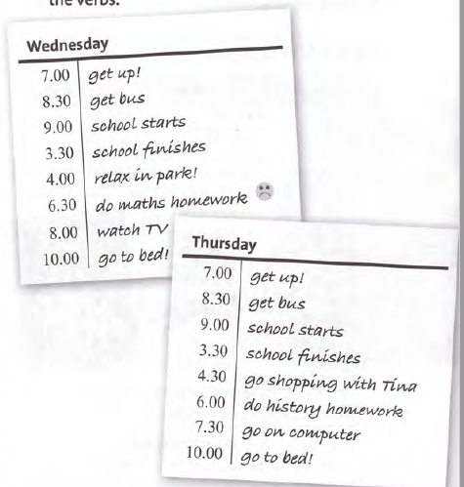

**6/3 Complete the text:**

My sister **gets up** at 7 a.m. and she _________ the bus to school at 8.30 a.m.

School ________________ at 9 a.m. and it finishes at 3.30 p.m. After school on Wednesdays, she ____________ with her friends. On Thursdays, she _________ shopping in town. In the evening, she___________________ her homework

and then she ________________ TV or goes on the computer and chats with her friends. She ______________ to bed at 10 p.m.

**7/3 Present simple and present continuous**

**Complete the phone conversation. Use**

**the present simple or the present continuous**

**form of the verbs in brackets.**

Mum Hi, Ollie. It's Mum. **I'm coming** (come) home now.

Ollie OK, Mum.

Mum 1________________ (you / study) for your important exam?

Ollie No, I _________________ (chat) to Sirr:lOn.

We 3 ________________ (talk) about the exam.

Mum But you 4 ______________ (talk) to him every day.

Ollie No, we 5 __________________ (not chat) in class. We 6__________ (listen) to our teacher.

Mum Are you sure? What 7 ________________ (your sister / do) at the moment?

8 ________________________(she / do) her homework?

Ollie No, of course not, Mum. She never ___________________9 (do) her homework. She __________________10 (watch) TV, I think!